
Faculty of Science

Course: CSCI 2020u – Software System Development & Integration
Component: Assignment
Weight: 10%
Deadline: March 6, 2019 (due by 11:59pm)

GITHUB LINK: https://github.com/jeremydavidfriesen/CSCI2020uAssignment

Collaboration Policy
You are permitted to work on this assignment in a team, and submit the results as a team. For this sort of assignment, with an open-ended component, the collaboration between multiple team members can be beneficial. Between groups, however, please limit the discussion to the level of general strategy (not code). Groups of size 2 are recommended. Larger groups will be considered with the proviso that the marker will mark your assignment with higher expectations. In any case, be sure that all members of the team fully understand all code, otherwise they will miss intended learning objectives, which may be a considerable disadvantage at exam time.

How to Submit
You will maintain a git repository for this assignment, which is a public repository. To submit the assignment, create a single file ‘README.txt’ that contains instructions on how to download, compile, and run your codes for each question. A .zip, .7z, or .rar file will not be acceptable. Also submit this word file (once you complete) into related drop box on Blackboard before deadline.

Note: Comments are mandatory. Failure to properly document your program will result in a deduction on the marks you receive for this (and any other) assignment.

Remember:
You need to complete this file and submit it in related drop box on Blackboard, in addition to uploading your codes in your git repository, before deadline.

Question 1: Displaying Three Cards

Problem Description:
Display a frame that contains three labels. Each label displays a card, as shown in the figure below. The card image files are named 1.png, 2.png, ..., 54.png and stored in the image/card directory. All three cards are distinct and selected randomly.

The image icons can be found in the attached card folder.

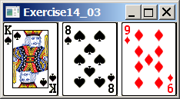

Your Task:
- Create three ImageView and set their icons using the images.
- Display three images from 54 image cards randomly.

Your Code:
Copy-paste your code here:

// Jeremy Friesen
// 100649797
// DisplayCards
// This program displays 3 unique cards from a deck of cards
package sample;
import javafx.application.Application;
import javafx.scene.Scene;
import javafx.scene.layout.GridPane;
import javafx.stage.Stage;
import javafx.scene.image.ImageView;
import java.util.Random;
import static java.lang.Math.abs;
public class DisplayCards extends Application{
@Override
public void start(Stage primaryStage) throws Exception{
// array to track used cards
int[] used = new int[2];
Random rand = new Random();
GridPane pane = new GridPane();
// draw three cards
for(int i = 0; i < 3; i++) {
int cardNumber;
// pick new card while the card drawn has already been picked
do{
cardNumber = abs(rand.nextInt()) % 54 + 1;
}while(cardNumber == used[0] || cardNumber == used[1]);
// display card
ImageView img = new ImageView("Cards/" + cardNumber + ".png");
pane.add(img, i, 0);
// add card to used cards
if(used[0] == 0){
used[0] = cardNumber;
}else{
used[1] = cardNumber;
}
}
Scene scene = new Scene(pane);
primaryStage.setScene(scene);
primaryStage.show();
}
public static void main(String[] args) {
launch(args);
}
}

Screen shots:
Include two screen shots here:

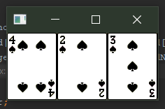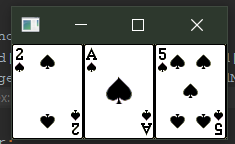

Question 2: Investment-Value calculator

Problem Description:
Write a program that calculates the future value of an investment at a given interest rate for a specified number of years. The formula for the calculation is as follows:

futureValue = investmentAmount * (1 + monthlyInterestRate)years*12

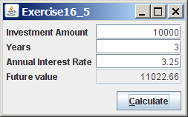

Your Task:
Use text fields for interest rate, investment amount, and years. Display the future amount in a text field when the user clicks the Calculate button, as shown in the figure.

Your Code:
Copy-paste your code here.
// Jeremy Friesen
// 100649797
// investmentCalculator
// This program calculates the future value of an investment
// using the original investment, the # of years passed, and the rate of return
package sample;
import javafx.application.Application;
import javafx.geometry.HPos;
import javafx.geometry.Insets;
import javafx.geometry.Pos;
import javafx.scene.Scene;
import javafx.scene.control.Button;
import javafx.scene.control.Label;
import javafx.scene.control.TextField;
import javafx.scene.layout.GridPane;
import javafx.stage.Stage;
import javafx.event.ActionEvent;
import javafx.event.EventHandler;
public class investmentCalculator extends Application{
public TextField tfInvestment = new TextField();
public TextField tfYears = new TextField();
public TextField tfRate = new TextField();
public TextField tfFutureValue = new TextField();
@Override
public void start(Stage primaryStage) {
GridPane pane = new GridPane();
pane.setAlignment(Pos.CENTER);
pane.setPadding(new Insets(11.5, 12.5, 13.5, 14.5));
pane.setHgap(5.5);
pane.setVgap(5.5);
// add TextFields for user to input values
pane.add(new Label("Investment Amount"), 0, 0);
pane.add(tfInvestment, 1, 0);
pane.add(new Label("Years"), 0, 1);
pane.add(tfYears, 1, 1);
pane.add(new Label("Annual Interest Rate"), 0, 2);
pane.add(tfRate, 1, 2);
pane.add(new Label("Future Value"), 0, 3);
// add futureValue field
tfFutureValue.setEditable(false);
pane.add(tfFutureValue, 1, 3);
// add "Calculate" button
Button btRegister = new Button("Calculate");
pane.add(btRegister, 1, 4);
GridPane.setHalignment(btRegister, HPos.LEFT);
// assign ButtonHandler to button
ButtonHandler handler1 = new ButtonHandler();
btRegister.setOnAction(handler1);
// Create a scene and place it in the stage
Scene scene = new Scene(pane, 360, 190);
primaryStage.setTitle("Exercise16_5");
primaryStage.setScene(scene);
primaryStage.show();
}
class ButtonHandler implements EventHandler<ActionEvent> {
@Override
public void handle(ActionEvent e) {
// get the value of each input field
double investmentAmount = Double.valueOf(tfInvestment.getText());
double monthlyInterestRate = Double.valueOf(tfRate.getText()) / 12.0 / 100.0;
double years = Double.valueOf(tfYears.getText());
// calculate future value
double futureValue = investmentAmount * Math.pow(1 + monthlyInterestRate, years * 12.0);
// display future value
tfFutureValue.setText(String.valueOf(Math.round(futureValue*100.0)/100.0));
}
}
public static void main(String[] args) {
launch(args);
}
}

Screen shots:
Include two screen shots here:

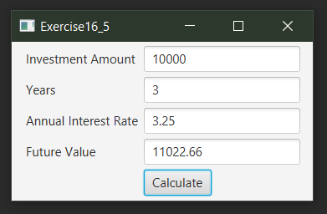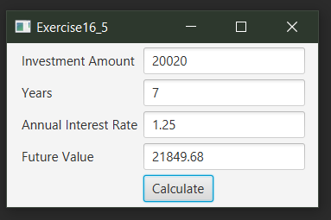

Question 3: Dragging Points on a Circle

Problem Description:
Draw a circle with three random points on the circle. Connect the points to form a triangle. Display the angles in the triangle. Use the mouse to drag a point along the perimeter of the circle. As you drag it, the triangle and angles are redisplayed dynamically.

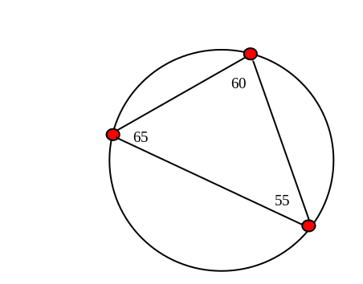

Here is the formula to compute angles:

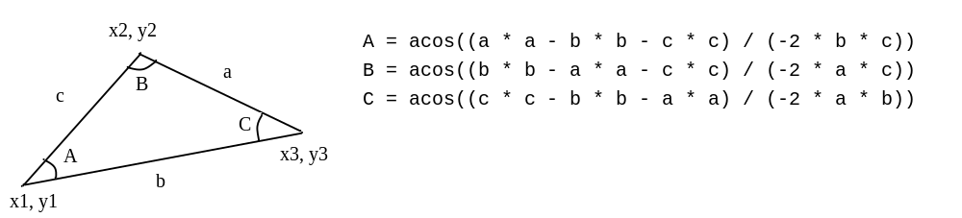

Your Code:
Copy-paste your code here:

// Jeremy Friesen
// 100649797
// CircleTriangle
// This program displays 3 points on the perimeter of a circle, connected to form a triangle
// The user may click and drag to reposition these points, reforming the triangle
package sample;
import javafx.application.Application;
import javafx.geometry.Point2D;
import javafx.scene.Scene;
import javafx.scene.layout.Pane;
import javafx.scene.paint.Color;
import javafx.scene.shape.Line;
import javafx.stage.Stage;
import javafx.scene.shape.Circle;
import javafx.scene.text.Text;
import javafx.scene.input.MouseEvent;
import static java.lang.Math.*;
public class CircleTriangle extends Application{
@Override
public void start(Stage stage){
Pane pane = new Pane();
// Create circle
Circle circle = new Circle();
circle.setCenterX(120);
circle.setCenterY(120);
circle.setRadius(100);
circle.setStroke(Color.BLACK);
circle.setFill(Color.WHITE);
// Initialize triangle points
Circle[] points = new Circle[3];
for(int i = 0; i < 3; i++){
points[i] = new Circle();
points[i].setFill(Color.RED);
points[i].setStroke(Color.BLACK);
points[i].setRadius(5);
}
points[0].setCenterX(20);
points[0].setCenterY(120);
points[1].setCenterX(120);
points[1].setCenterY(20);
points[2].setCenterX(220);
points[2].setCenterY(120);
// Initialize triangle edges
Line[] lines = new Line[3];
lines[0] = new Line(points[0].getCenterX(), points[0].getCenterY(),
points[1].getCenterX(), points[1].getCenterY());
lines[1] = new Line(points[1].getCenterX(), points[1].getCenterY(),
points[2].getCenterX(), points[2].getCenterY());
lines[2] = new Line(points[2].getCenterX(), points[2].getCenterY(),
points[0].getCenterX(), points[0].getCenterY());
// Initialize triangle angle text
Text[] angles = new Text[3];
angles[0] = new Text(points[0].getCenterX() + 10, points[0].getCenterY() + 10, "");
angles[1] = new Text(points[1].getCenterX() + 10, points[1].getCenterY() + 10, "");
angles[2] = new Text(points[2].getCenterX() + 10, points[2].getCenterY() + 10, "");
angles[0].setText(String.valueOf(calculateAngle(lines[0], lines[2], lines[1])));
angles[1].setText(String.valueOf(calculateAngle(lines[1], lines[0], lines[2])));
angles[2].setText(String.valueOf(calculateAngle(lines[2], lines[1], lines[0])));
// When the user drags the mouse, update the point and set text for each angle
points[0].setOnMouseDragged(e -> {
updatePoint(points[0], circle, e, lines[0], lines[2], lines[1], angles[0]);
angles[1].setText(String.valueOf(calculateAngle(lines[1], lines[0], lines[2])));
angles[2].setText(String.valueOf(calculateAngle(lines[2], lines[1], lines[0])));
});
points[1].setOnMouseDragged(e -> {
updatePoint(points[1], circle, e, lines[1], lines[0], lines[2], angles[1]);
angles[0].setText(String.valueOf(calculateAngle(lines[0], lines[2], lines[1])));
angles[2].setText(String.valueOf(calculateAngle(lines[2], lines[1], lines[0])));
});
points[2].setOnMouseDragged(e -> {
updatePoint(points[2], circle, e, lines[2], lines[1], lines[0], angles[2]);
angles[1].setText(String.valueOf(calculateAngle(lines[1], lines[0], lines[2])));
angles[0].setText(String.valueOf(calculateAngle(lines[0], lines[2], lines[1])));
});
// Add all objects to pane
pane.getChildren().addAll(circle, lines[0], lines[1], lines[2],
points[0], points[1], points[2],
angles[0], angles[1], angles[2]);
Scene scene = new Scene(pane, 240, 240);
stage.setScene(scene);
stage.show();
}
public static void main(String[] args) {
launch(args);
}
// Bind point to the perimeter of the circle
private void followCircle(Circle point, Circle circle, MouseEvent e){
Point2D circleCenter = new Point2D(circle.getCenterX(), circle.getCenterY());
Point2D mousePos = new Point2D(e.getX(), e.getY());
Point2D newPoint = mousePos.subtract(circleCenter).normalize().multiply(circle.getRadius()).add(circleCenter);
point.setCenterX(newPoint.getX());
point.setCenterY(newPoint.getY());
}
// update the point location, angle text and angle text position
private void updatePoint(Circle point, Circle circle, MouseEvent e, Line lineA, Line lineB, Line lineC, Text angle){
followCircle(point, circle, e);
lineA.setStartX(point.getCenterX());
lineA.setStartY(point.getCenterY());
lineB.setEndX(point.getCenterX());
lineB.setEndY(point.getCenterY());
if(point.getCenterX() < circle.getCenterX()){
angle.setX(point.getCenterX() + 10);
} else {
angle.setX(point.getCenterX() - 10);
}
if(point.getCenterY() < circle.getCenterY()){
angle.setY(point.getCenterY() + 10);
} else {
angle.setY(point.getCenterY() - 10);
}
angle.setText(String.valueOf(calculateAngle(lineA, lineB, lineC)));
}
// calculate the angle of the vertex
private int calculateAngle(Line lineA, Line lineB, Line lineC){
double a = lineLength(lineA);
double b = lineLength(lineB);
double c = lineLength(lineC);
return (int)Math.round(Math.toDegrees(acos((c * c - b * b - a * a) / (-2 * b * a))));
}
// calculate the length of a given javafx.scene.shape.Line
private double lineLength(Line line){
double xDist = line.getStartX() - line.getEndX();
double yDist = line.getStartY() - line.getEndY();
return sqrt(xDist*xDist + yDist*yDist);
}
}

Screen shots:
Include two screen shots here:

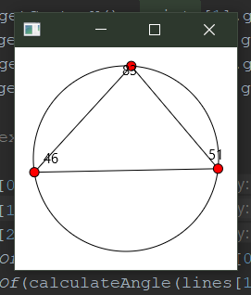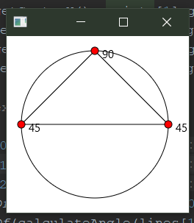

Question 4: Histogram

Problem Description:
Develop a program that displays a histogram to show the occurrences of each letter in a text area. The histogram should show the occurrences of each letter in a text file, as shown in the following figure. Assume that the letters are not case sensitive.

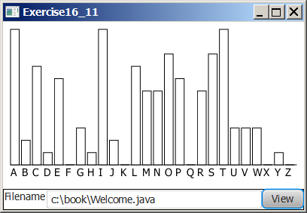

Your Task:
- Place a pane that will display the histogram in the center of the frame.
- Place a label and a text field in a panel, and put the panel in the south side of the frame. The text file will be entered from this text field.
- Pressing the Enter key on the text field causes the program to count the occurrences of each letter and display the count in a histogram.

Your Code:
Copy-paste your code here:
// Jeremy Friesen
// 100649797
// Histogram
// Displays a histogram with the count of occurrences of each letter in a text file
// The user may enter the path to their own text file, and the histogram will graph it
package sample;
import javafx.application.Application;
import java.io.File;
import java.lang.*;
import java.util.Scanner;
import javafx.scene.Scene;
import javafx.scene.chart.CategoryAxis;
import javafx.scene.chart.NumberAxis;
import javafx.scene.chart.XYChart;
import javafx.scene.control.Button;
import javafx.scene.control.TextField;
import javafx.scene.layout.GridPane;
import javafx.scene.layout.HBox;
import javafx.stage.Stage;
import javafx.scene.chart.BarChart;
import static java.lang.Character.toUpperCase;
public class Histogram extends Application {
private char[] alphabet = {'A', 'B', 'C', 'D', 'E', 'F', 'G', 'H', 'I', 'J', 'K', 'L', 'M',
'N', 'O', 'P', 'Q', 'R', 'S', 'T', 'U', 'V', 'W', 'X', 'Y', 'Z'};
private String[] alphabetStr = {"A", "B", "C", "D", "E", "F", "G", "H", "I", "J", "K", "L", "M",
"N", "O", "P", "Q", "R", "S", "T", "U", "V", "W", "X", "Y", "Z"};
private int[] occurrences = {1, 2, 3, 4, 5, 6, 7, 8, 9, 10, 11, 12, 13, 14,
15, 16, 17, 18, 19, 20, 21, 22, 23, 24, 25, 26};
private File file = new File("text.txt");
@Override
public void start(Stage primaryStage) throws Exception{
GridPane pane = new GridPane();
HBox hbox = new HBox();
// Initialize Bar Chart
final CategoryAxis xAxis = new CategoryAxis();
final NumberAxis yAxis = new NumberAxis();
final BarChart<String,Number> bc = new BarChart<String,Number>(xAxis,yAxis);
XYChart.Series series = new XYChart.Series();
for(int i = 0; i < 26; i++){
series.getData().add(new XYChart.Data(alphabetStr[i], occurrences[i]));
}
bc.getData().add(series);
pane.add(bc,0,0);
// Initialize input textField and button
TextField textField = new TextField();
Button button = new Button("View");
// set button action
button.setOnAction(e -> {
try {
// make new text file with user-input filepath
file = new File(textField.getText());
readFile();
// add data to Bar Chart
XYChart.Series s = new XYChart.Series();
for(int i = 0; i < 26; i++){
s.getData().add(new XYChart.Data(alphabetStr[i], occurrences[i]));
}
bc.getData().add(s);
} catch(Exception err){
System.out.println(err.getMessage());
}
});
hbox.getChildren().addAll(textField, button);
pane.add(hbox, 0, 1);
Scene scene = new Scene(pane);
primaryStage.setScene(scene);
primaryStage.show();
readFile();
}
// Read in designated file and increase occurrences according to the characters in that file
public void readFile() throws Exception {
if(file.exists()) {
occurrences = new int[26];
Scanner input = new Scanner(file);
input.useDelimiter("");
while (input.hasNext()) {
char c = toUpperCase(input.next().charAt(0));
for(int i = 0; i < 26; i++){
if(alphabet[i] == c){
occurrences[i]++;
break;
}
}
}
input.close();
} else {
System.out.println("Error: file \"" + file.getName() + "\" does not exist.");
}
}
public static void main(String[] args) {
launch(args);
}
}

Screen shots:
Include two screen shots here:
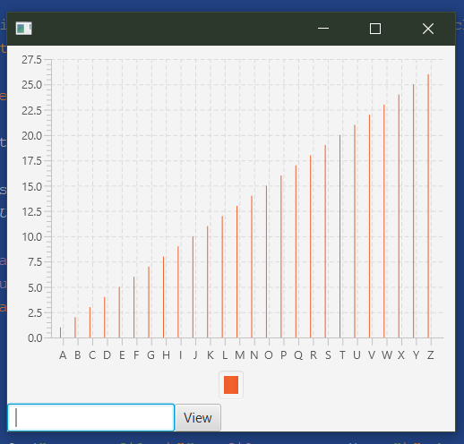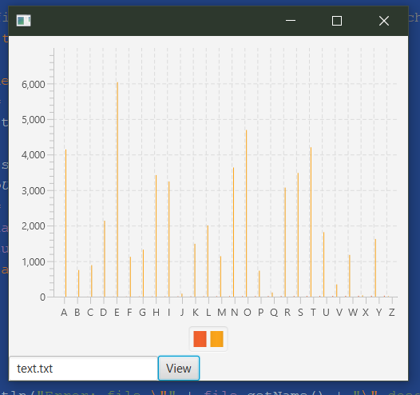
Remember:

You need to complete this file and submit it in related drop box on Blackboard, in addition to uploading your codes in your git repository, before deadline.

